Visual story:
Accessing the ‘Spinifex People: Art and stories from Pila Nguru’ Exhibit

A step-by-step visual and written guide for visitors attending the ‘Spinifex People: Art and stories from Pila Nguru’ exhibit.

What is a Visual Story?

Visual stories are simple and easy to follow. They help people get ready for new places or situations by making things more predictable.

This makes the process feel familiar and reduces anxiety and stress.

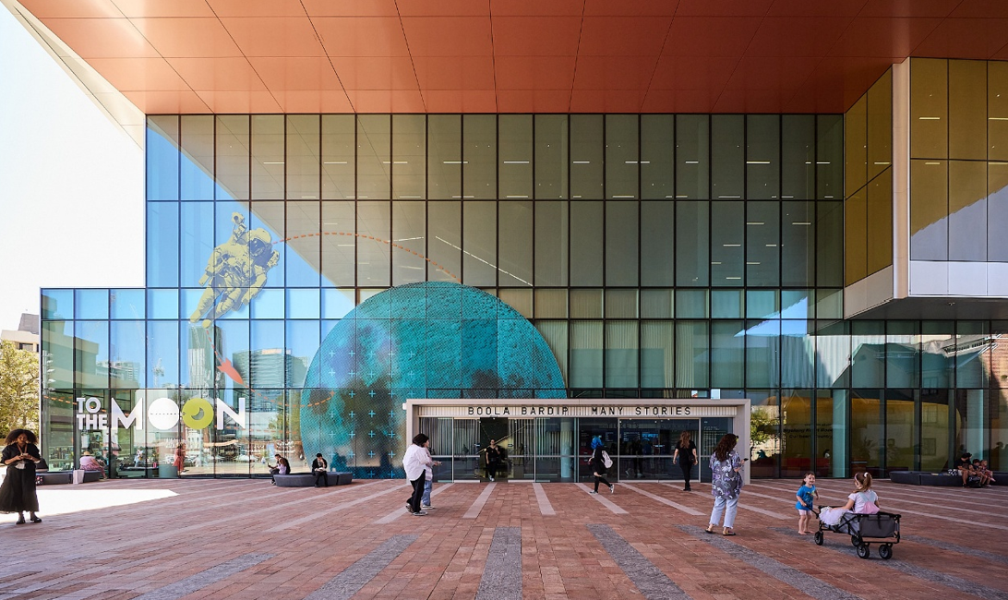

The WA Museum Boola Bardip is located in the Perth Cultural Centre on James Street, Northbridge.
To get there:

- Go to the Perth Cultural Centre on James Street, Northbridge.

- The museum is open every day from 9:30 am to 5:00 pm.

- You can take the free blue CAT bus, or walk from Perth Train station.
- Inside, you will find many interesting displays, including the ‘Spinifex People: Art and stories from Pila Nguru’ exhibit.

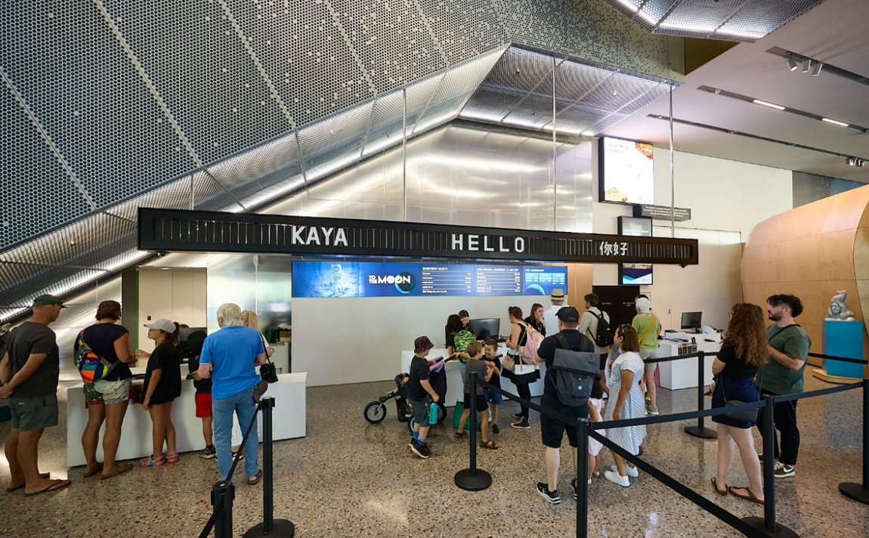

Once you walk in, you can line up for general admission tickets (Museum is free until 31 March). There is plenty of room for prams and wheelchairs. This is the Ground Floor.
The WA Museum is part of the Companion Card program. If you have a Companion Card, you can get free entry for your companion.

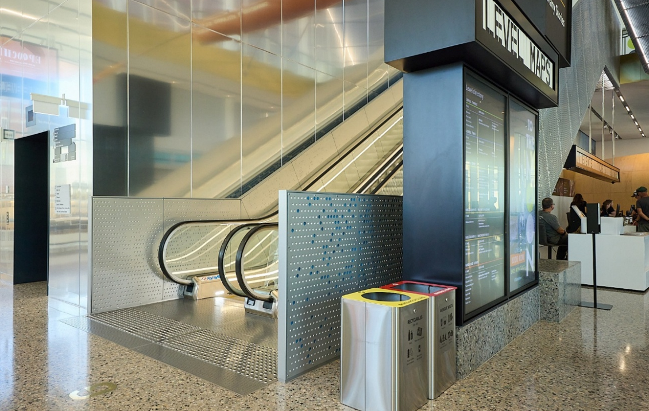
Once you have purchased your General Admission ticket, if you turn left, you will see an escalator that will take you up to the exhibit. There are also elevators.
You will want to go to Level 1 for the ‘Spinifex People: Art and stories from Pila Nguru’ exhibit.

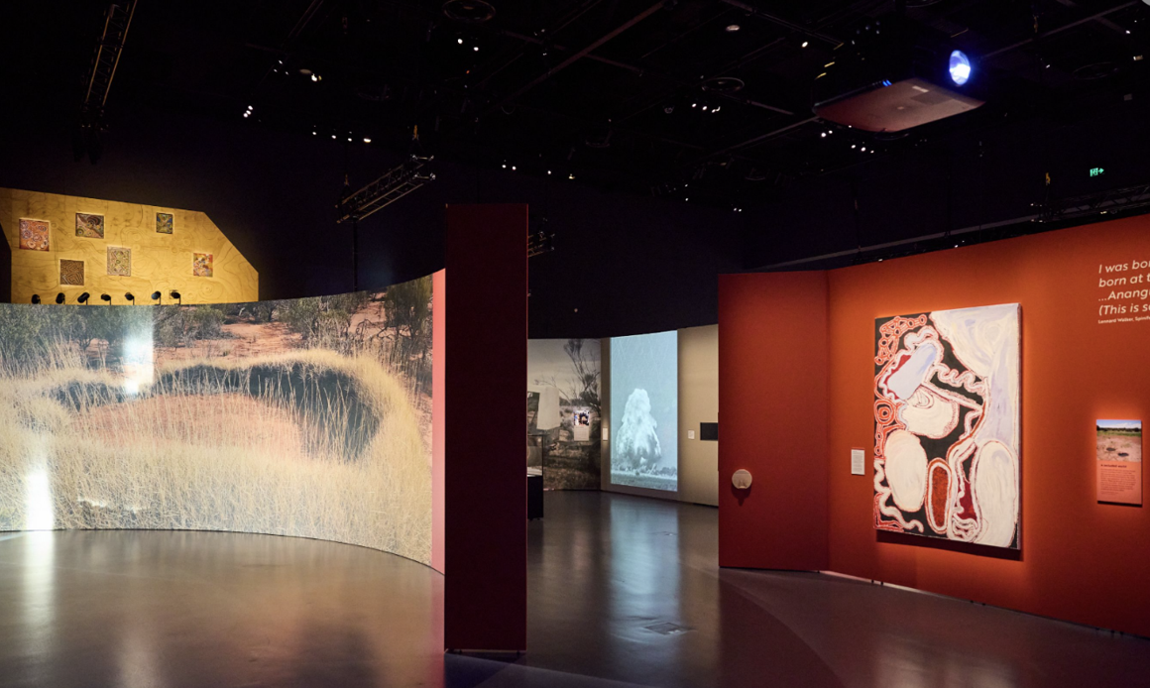

Welcome to the ‘Spinifex People: Art and stories from Pila Nguru’ exhibit, where the stories of the Spinifex People come alive.

Born in the heart of the Great Victoria Desert, the Spinifex People have a deep connection to their Country.

As you walk through this exhibit, you will hear their voices, see their art, and experience their history.

This exhibit celebrates the Spinifex Arts Project and the Tjuntjuntjara Community, where, as the Spinifex artists say, 'the old people were born in this Country and painting helped get this Country back'.

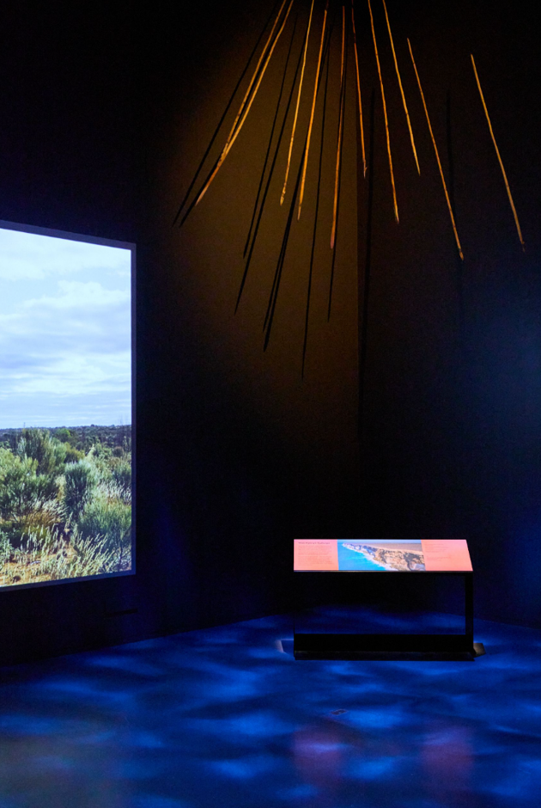

As you enter the exhibit, turn right. You will see a video screen playing images of traditional Spinifex Country landscapes. The room is dimly lit, with dappled light shining on the ground, like the natural environment of the desert.
Look up to discover a carefully curated display of traditional tools and artifacts.

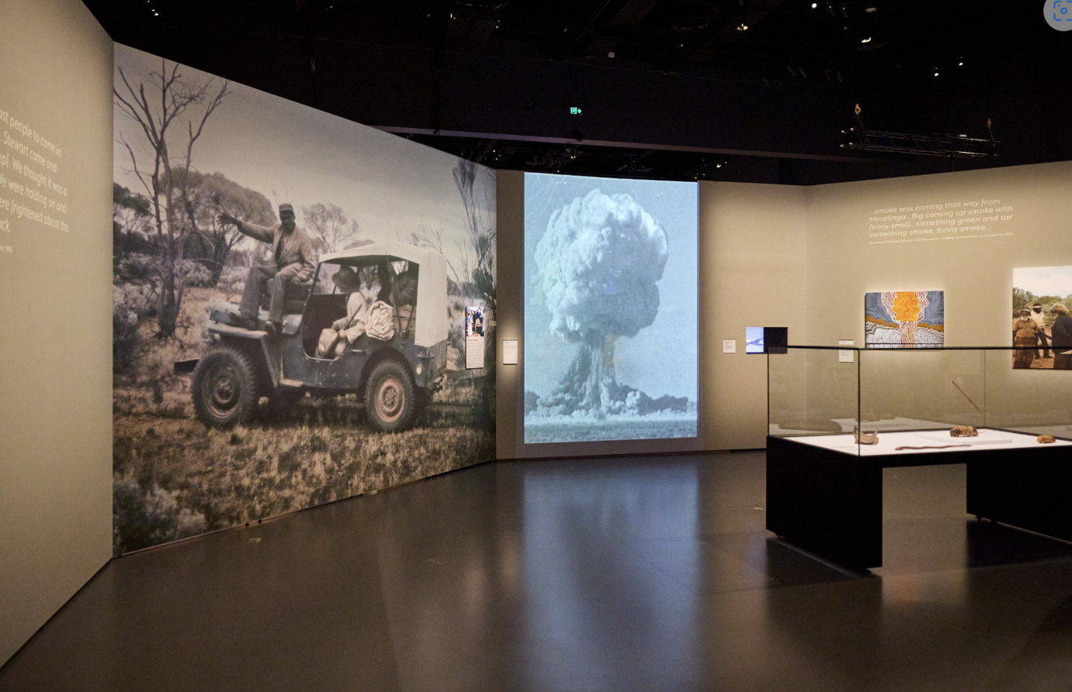

As you continue through the exhibit, you will enter a space that acknowledges a significant and complex chapter in the history of the Spinifex People.

In 1956, the British government conducted nuclear testing at Maralinga, within Spinifex Country, as part of Operation Buffalo.

This testing had profound and lasting impacts on the land, the people, and their culture

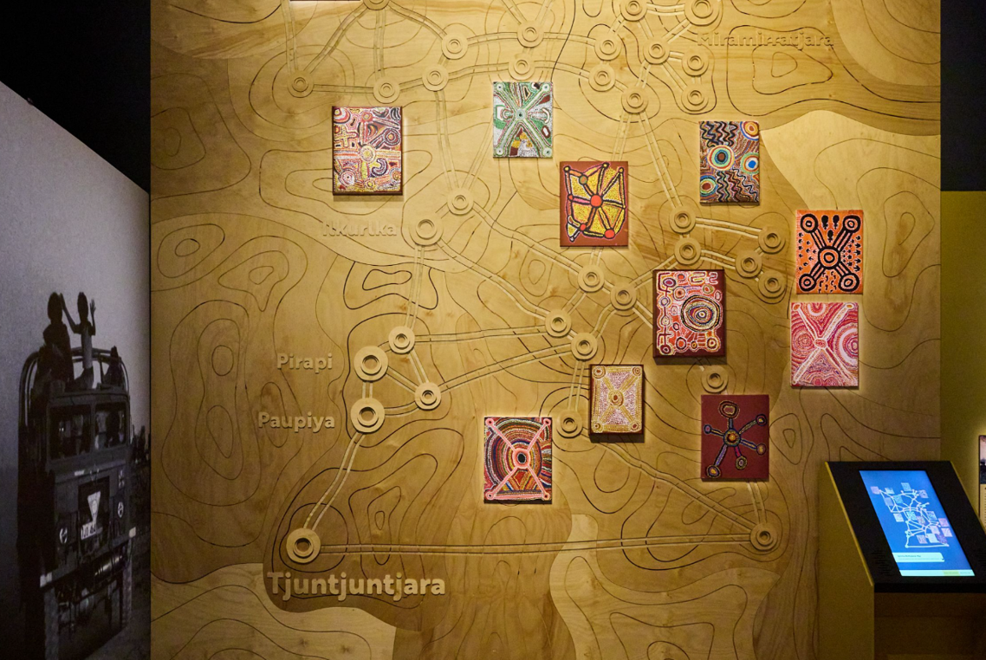

Step forward and see an entire wall installation, showcasing the Spinifex Country rockhole map. Towering above you, the golden map stretches across the wall, with each rockhole – including Ilkurlka, Pirapi, Paupiya, and Wartala – accompanied by a unique piece of artwork, created by Spinifex artists.

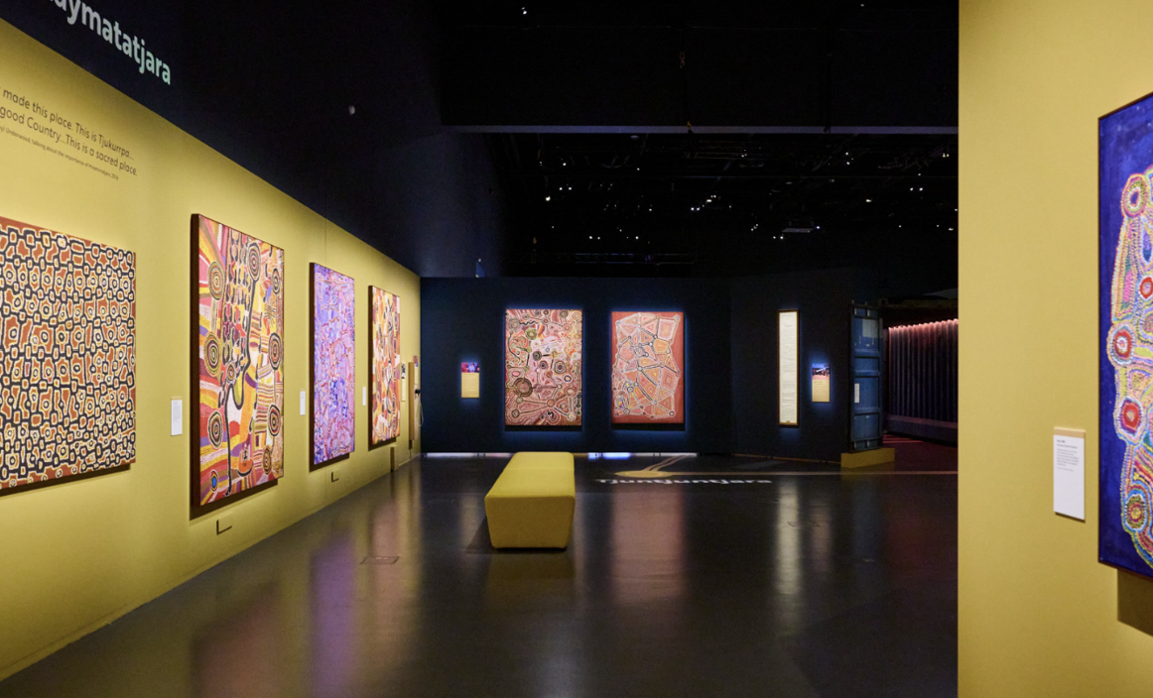
As you then step into this immersive space, you are surrounded by vibrant First Nations art. Have a seat and reflect, or walk around as you look at the art.

The earpieces on the wall invite you to listen in on moments in history, like Honourable Richard Court's reflections on the 1998 Framework Agreement.

Among the artworks on the wall is Pukara, a painting by the Spinifex Men's Collaborative.

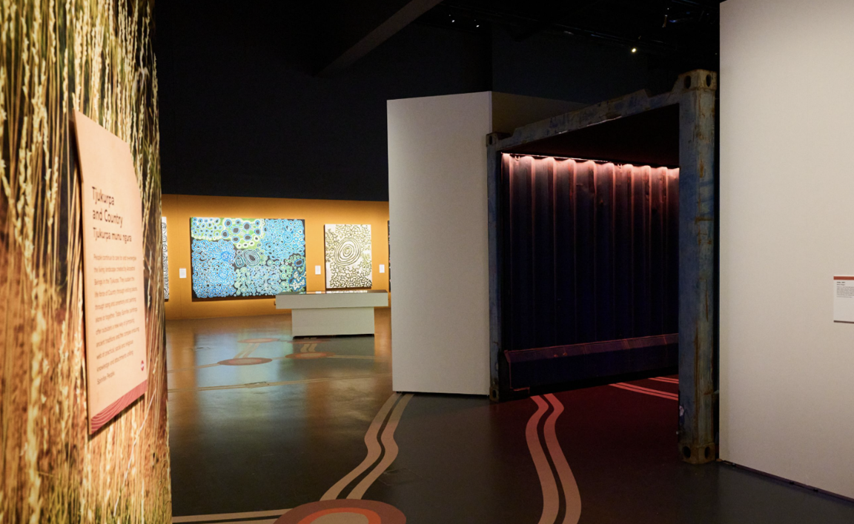

Look down at the ground. The same rockholes from the wall map are marked here, inviting you to explore further. Each one is a pathway to discover artworks inspired from significant Spinifex sites.

Step into the shipping container shed, its metal slats filtering the light. As you walk through, glimpses of images appear between the slats.
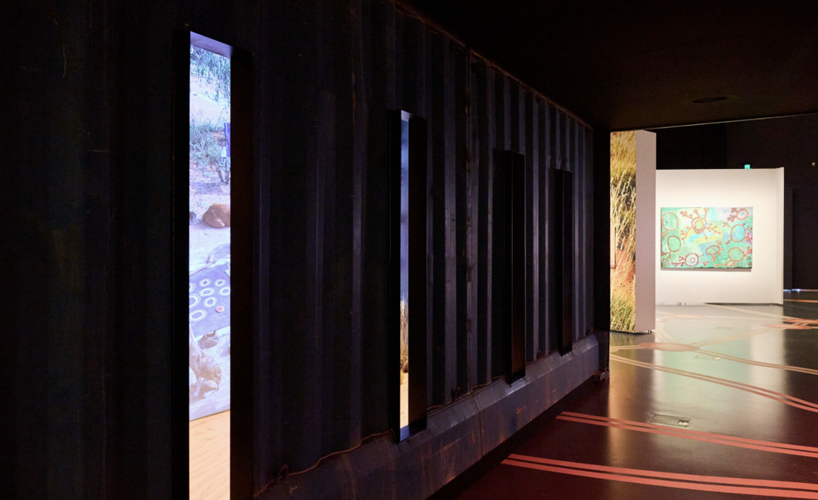

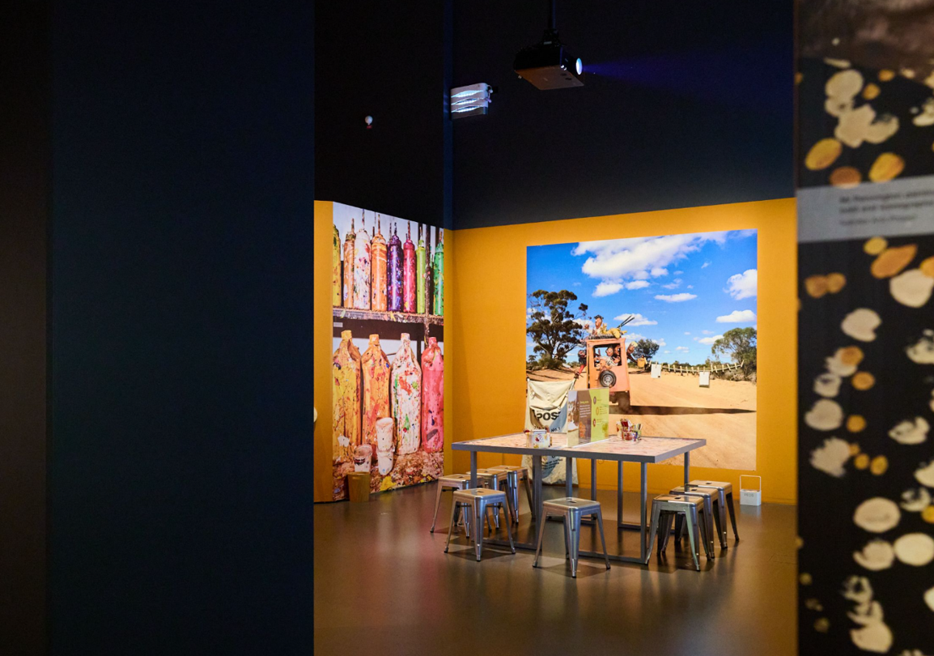

An activity not just for the kids!
Take a seat and reflect on your experience.
Now, share your thoughts, stories, or messages on a postcard, which will be sent to the community of Tjuntjunjara in Spinifex Country.
This is a meaningful way to connect with the people and land that inspired this exhibition.

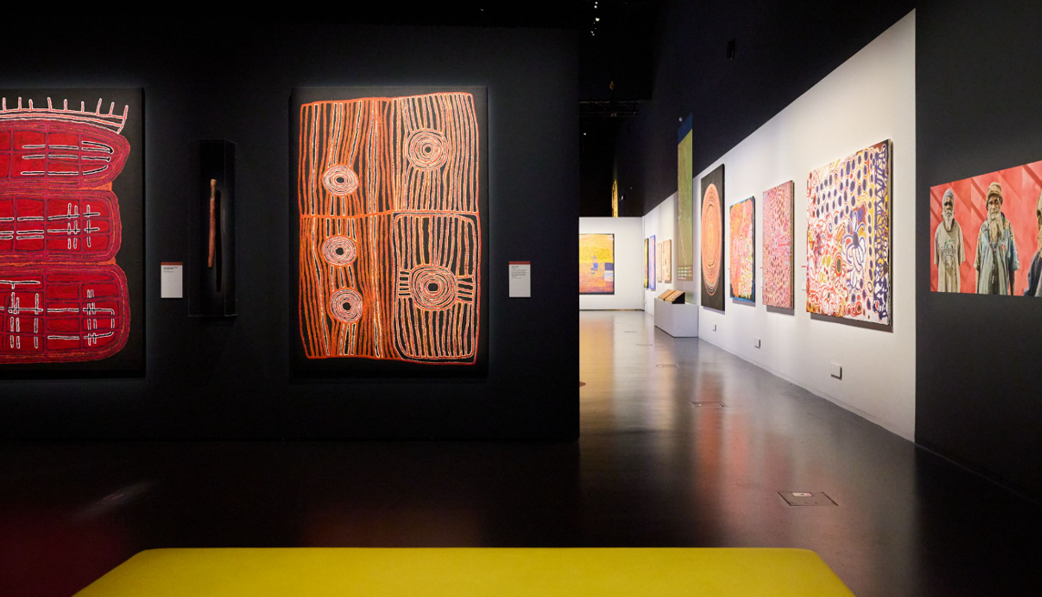

Take a moment to sit, reflect, and immerse yourself in the artworks created by Spinifex Artists.

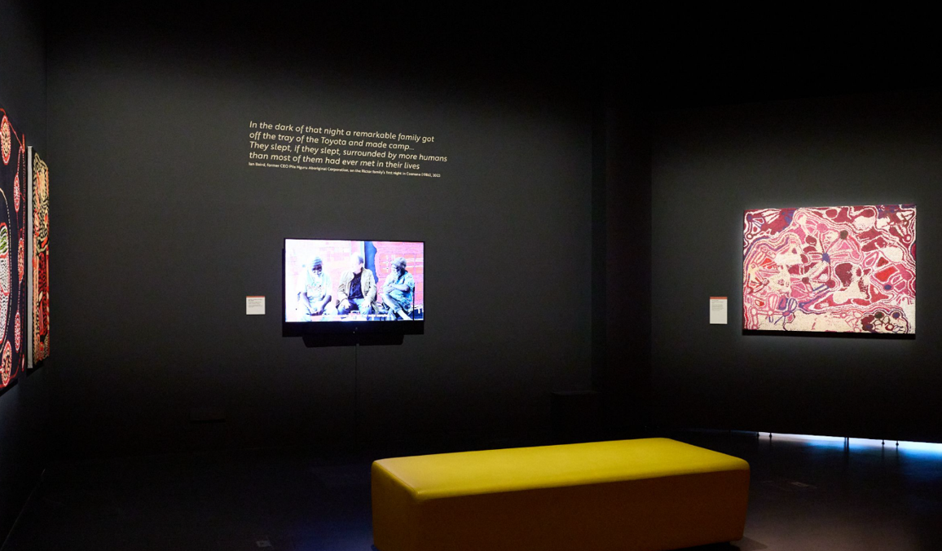

Sit and watch a video on the experiences of the artists.

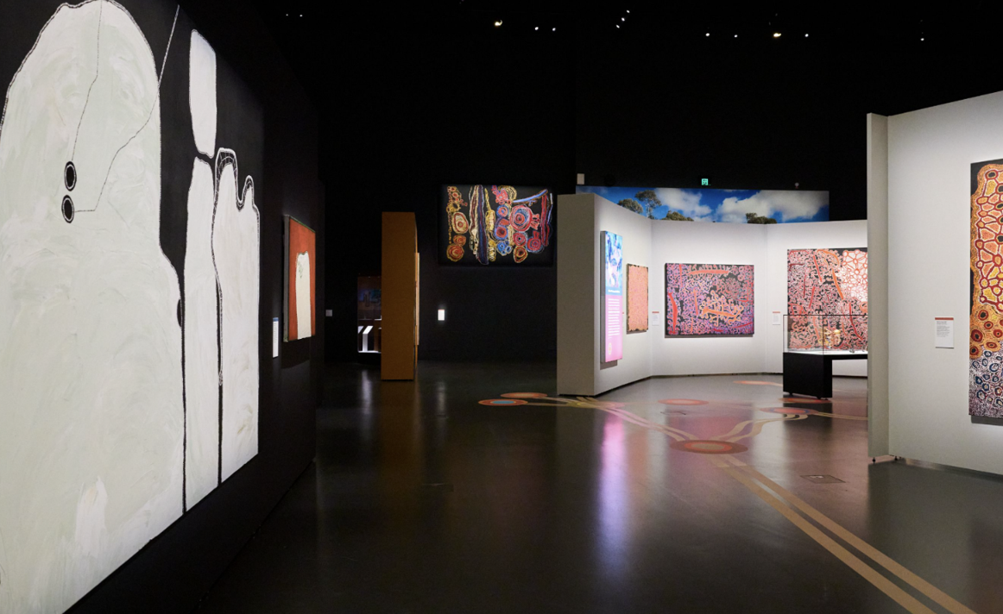

Take your time immersing yourself in more art and history about the Spinifex People and the Spinifex Art project.

That is the end of the exhibit. You can exit down the escalators.
We hope you have enjoyed your experience. Please come again soon!
We acknowledge the Whadjuk Noongar people as the Traditional Owners of the land on which we gather in Perth. We also pay our respects to the Spinifex people, whose stories and culture are shared with us through this exhibition.
If you want to know more about accessibility at the Boola Bardip WA Museum, read our Accessibility Visitor’s Guide.

